Sprint 1

Sprint 2

Sprint 3

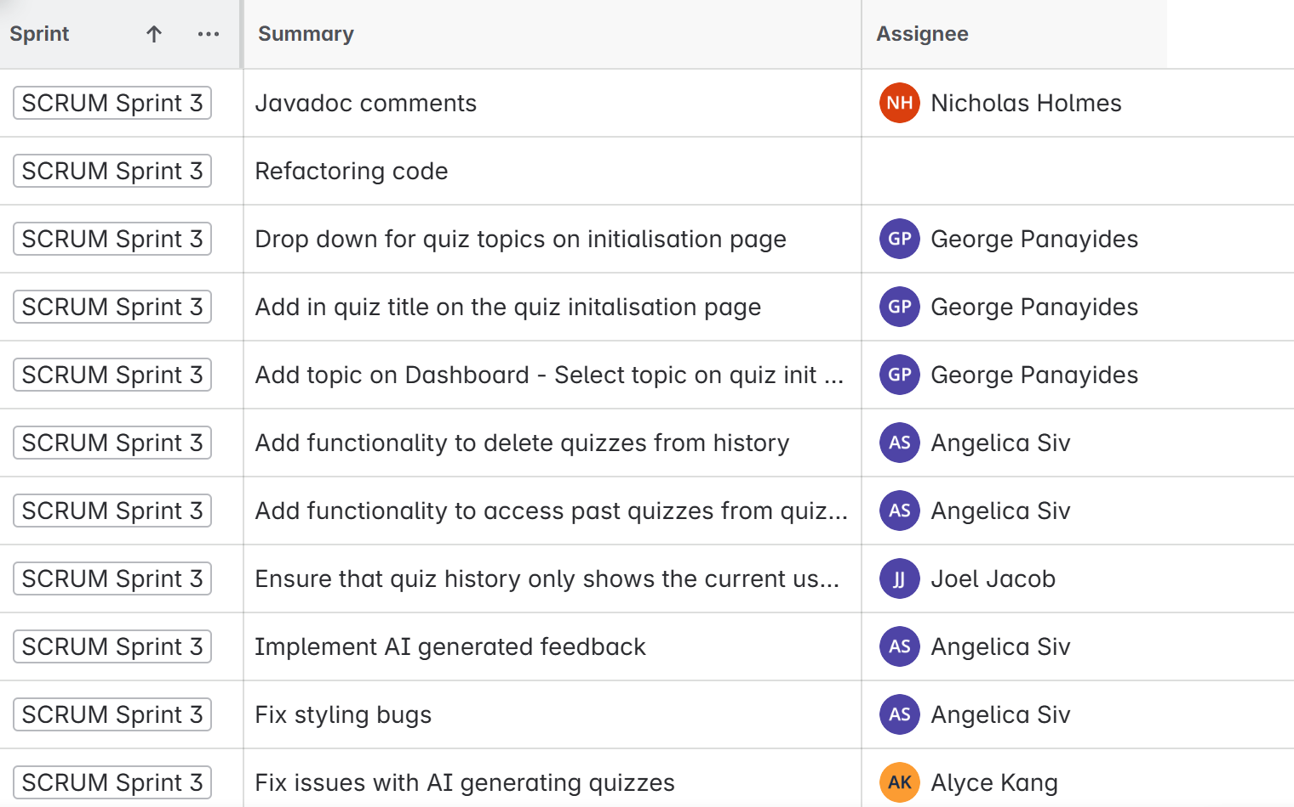

Note: Unassigned tasks were worked on by more than one person.